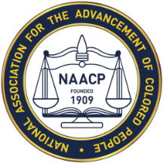NAACPALBEMARLE-CHARLOTTESVILLE UNIT 7057-B
PO BOX 1522
CHARLOTTESVILLE, VA. 22903

MEMBERSHIP REGISTRATION FORM
The NAACP has been leading the effort for social justice for over 111 years! Founded in 1909 and headquartered in Baltimore, Maryland, the organization is comprised of seven regions that represent 49 states, 5 countries and the District of Columbia. The organization continues to be at the forefront, addressing issues that are paramount in our communities: aimed at eliminating disparities in economic development, health care, education, technology, and many other issues.
TAKE A STAND – JOIN THE NAACP TODAY!

Membership Status (check one): NEW: _____ RENEWAL: _____ GIFT: _____ SUPPORT: _____

PLEASE PRINT LEGIBLY
DATE: _______________

____________________________________________________________________________________
TITLE ↑ FIRST NAME ↑ MIDDLE NAME ↑ ↑ LAST NAME
(Dr., Mr., Ms. Mrs., etc)

____________________________________________________________________________________
MAILING ADDRESS ↑

__________________________________________________________________________________________
CITY ↑ STATE ↑ ZIP CODE ↑

__________________________________________________________________________________________
TELEPHONE NUMBER ↑ EMAIL ADDRESS ↑

Youth Membership ONLY: Solicitor/Sponsor Name:_________________________________________
Date of Birth of Youth Member: Month:___________ Day:______ Year:___________

Payment Options: ___Cash ___Check | *Make check payable to: Albemarle-Charlottesville NAACP #7057-B
Credit Card: Card #___________________________ Type ____ Exp. Date ___ ___ CVC____ Zip Code _____
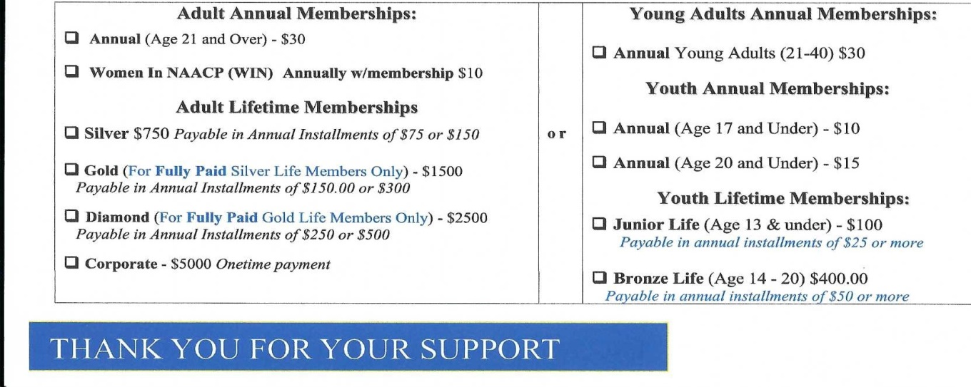
Email:naacp1947@gmail.com Web: www.Albemarle-Cvillenaacp.org

