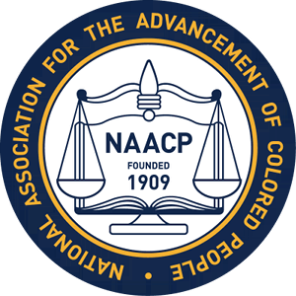

The Albemarle- Charlottesville Branch
NAACP
presents its annual
FREEDOM FUND BANQUET
“DEFEAT HATE……..VOTE!”

FRIDAY SEPTEMBER 28, 2018
CHARLOTTESVILLE DOUBLETREE HOTEL
Cash Bar & Silent Auction
(6:00---7:00 PM)
Program – 7:00 - Dinner – 7:30 PM

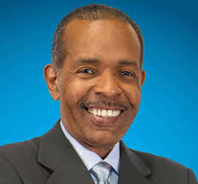

Keynote Speaker
JOE MADISON
Known as “The Black Eagle”, Joe Madison is a legendary voice in radio, and a recognized human and civil rights activist.
Tickets - $85
Tables are also available:
Table of 8 - $650 - Table of 10 - $800

Contributions or gifts to this unit are generally not deductible as charitable contributions for federal income tax purposes.

Make checks payable to: Albemarle-Charlottesville NAACP
Send to: Albemarle-Charlottesville NAACP - P.O. Box 1522 Charlottesville, VA 22902
For further information & tickets, contact:
Lynn Boyd – 434 806-9449 or Janice Spellman -434-465-468

