[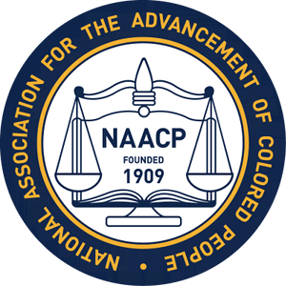](https://thumbs.dreamstime.com/z/people-communicating-colorful-silhouettes-holding-speech-balloons-communication-concept-white-background-40256743.jpg)



**Albemarle-Charlottesville NAACP**

**Direct Advocacy Training**

**(Saturday) August 12, 2017**

**Jackson P. Burley Middle School**

**901 Rose Hill Drive**

**Charlottesville, VA.**

**11:00 AM - 2:00 PM**

**(FREE Event)\***

**\*Registration Required:**

**Call – (434) 220-1493 or**

**Email:** [**naacp1947@gmail.com**](mailto:naacp1947@gmail.com)

**PLEASE LEAVE NAME/ADDRESS/OR EMAIL ADDRESS**

**This training will focus on helping people understand how to properly respond to the negative ideas and actions of others while maintaining a safe environment when expressing ideas and concerns.**