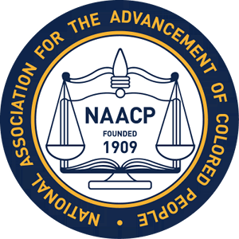

ALBEMARLE-CHARLOTTESVILLE
NAACP
2019 LOBBY DAY PARTICIPANTS
President Janette B. Martin
Area Chair Melvin Burruss
Donna Price
Lynn M. Boyd

