ALBEMARLE-CHARLOTTESVILLE naacp
Celebrates
FOUNDERS DAY
“ENOUGH”
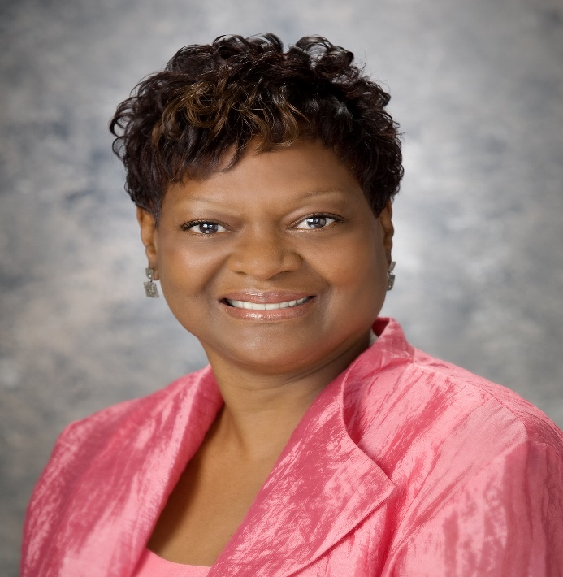
Delores L. McQuinn
Virginia House of Delegates
Seventieth District
Sunday, February 17, 2019
4:00P.M.
Zion Union Baptist Church
1015 Preston Avenue
Charlottesville, Virginia
Delegate Delores McQuinn was born in eastern Henrico County and has spent her entire life in the greater Richmond area. She studied at Virginia Commonwealth University and Virginia Union University and has demonstrated a lifelong commitment to improving the lives of others through public service. Her civic interest and involvement in politics began at the age of 11, when she campaigned for a candidate's successful election to Richmond City Council.
In 2009, Delegate McQuinn was elected to the Virginia House of Delegates to represent the 70th District, which includes parts of the City of Richmond, Henrico County and Chesterfield County.
Currently, she serves as the Central Virginia Regional Chair for the Safe Virginia Initiative, which addresses the need for reasonable gun legislation. She also is the founder and organizer of the East End Teen Center and its Summer Writing Institute. The Summer Program focuses on improving the literacy and writing talents of middle school youth.
Delegate McQuinn has also demonstrated an unwavering commitment to unveiling the true history and contributions of African Americans in this country and she chairs the Richmond Slave Trail Commission and The African American Cultural Resources (AACR) Task Force.
Delegate McQuinn has been acknowledged and honored on many occasions and some of her awards include but are not limited to: The YMCA’s Women of The Year, two African Diaspora World Tourism Awards, The Virginia Center for Inclusive Communities Humanitarian Award, and the Richmond African American History Month Award. Additionally, she is a member of numerous boards, organizations and committees which focus on uplifting and improving the Commonwealth.

