June 2018 Scholarships
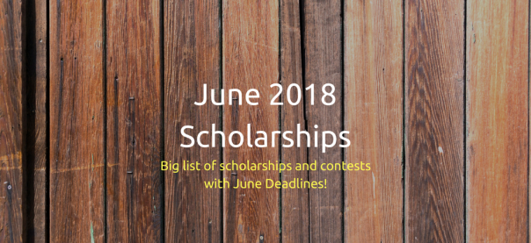
Attending college can be quite expensive for students and their families. Luckily, there are many college scholarships and contests available to help pay for a college education. Students should seek out and apply for scholarships in which they meet the eligibility requirements. Below are a handful of scholarships with June 2018 due dates. Check out the full list of June Scholarships – there are currently just under 300 scholarships on the list! More scholarships will be added as they become available.
Only brief information about each scholarship is listed. Therefore, students are encouraged to visit the scholarship websites to get further details about eligibility and requirements.
$500 High School Freshman Scholarship
Sponsor: Niche
Amount: $500
Closing Date: June 1, 2018
Description: Scholarship is open to legal residents of the United States or international students with a valid visa who are high school freshmen in the Class of 2021.
$500 High School Sophomore Scholarship
Sponsor: Niche
Amount: $500
Closing Date: June 1, 2018
Description: Scholarship is open to legal residents of the United States or international students with valid visa who are high school sophomores in the Class of 2020.
$500 High School Junior Scholarship
Sponsor: Niche
Amount: $500
Closing Date: June 1, 2018
Description: Scholarship is open to legal residents of the United States or international students with a valid visa who are high school juniors in the Class of 2019.
$500 High School Senior Scholarship
Sponsor: Niche
Amount: $500
Closing Date: June 1, 2018
Description: Scholarship is open to legal residents of the United States or international students with a valid visa who are high school seniors in the Class of 2018.
Americanism Elementary School Poster Contest
Sponsor: Sons of the American Revolution
Amount: Varies
Closing Date: 06 June 01, 2018
Description: Contest is open to students in grades 3-5. Contestant must create a poster on a given topic related to the Revolutionary War. Student must submit entry to local chapter.
HelpTeaching.com Scholarship
Sponsor: HelpTeaching.com
Amount: $1,000
Closing Date: June 1, 2018
Description: Scholarship is open to current high school and college students located in the United States and Canada. Applicant must submit a short story or informational article for children.
Big Sun Scholarship… 2018
Sponsor: Big Sun Athletics
Amount: $500
Closing Date: June 19, 2018
Description: Scholarship is open to all student athletes who are high school seniors or current college students. Applicant must submit an essay on how their high school sports participation influenced them.
Delete Cyberbullying Scholarship Award
Sponsor: Delete Cyberbullying
Amount: $1,000
Closing Date: June 30, 2018
Description: Scholarship is open to U.S. citizens and permanent residents who are attending or planning to attend an accredited U.S. college or university for undergraduate or graduatestudies. Applicant must submit an essay on a given topic related to cyberbullying.
Digital Privacy Scholarship
Sponsor: Digital Responsibility
Amount: $1,000
Closing Date: June 30, 2018
Description: Scholarship is open to current high school, college, and graduate school students. Home school students are also eligible. Applicant must complete a short form and finish the following statement in 140-characters or less: “I’m taking responsibility for my digital profile by…”
Discover Student Loans Scholarship
Sponsor: Discover Financial Services
Amount: $10,000
Closing Date: June 30, 2018
Description: Scholarship is open to high school seniors and undergraduate students who are 16 years of age or older. Applicant must sign up to receive helpful tips on planning and paying for college and they will be automatically entered into the sweepstakes.
Do-Over Scholarship
Sponsor: Unigo
Amount: $1,500
Closing Date: June 30, 2018
Description: Scholarship is open to students 13 years of age or older who are legal residents of the 50 United States or the District of Columbia and are currently enrolled (or will enroll no later than the fall of 2024) in an accredited post-secondary institution of
National Don’t Text and Drive Scholarship
Sponsor: Goldberg & Osborne
Amount: $1,000
Closing Date: June 30, 2018
Description: Scholarship is open to students currently attending college or planning to attend college during the Fall 2018 semester. Applicant must pledge to not text and drive.
Poetry Card Contest
Sponsor: Blue Mountain Arts
Amount: Up to $350
Closing Date: June 30, 2018
Description: Contestant must submit an original poem.

