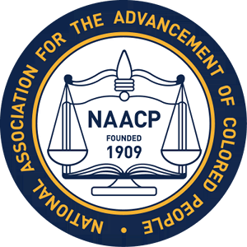

Albemarle- Charlottesville NAACP Holds Educational Workshop

The Albemarle - Charlottesville NAACP held an Educational workshop on Saturday, March 31​st​ at the Doubletree Hotel in Charlottesville. Dr. John L. Johnson former VSC Educational Chair, current Educational Phycologist and member of the VSC Executive Committee in Richmond, VA was the facilitator for the workshop. Dr. Johnson led the group in discussions, focusing on a variety of methods and procedures and their relevance to current educational issues. The Committee is comprised of NAACP members and will hold regular meetings with community input.

