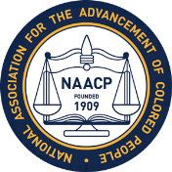
BRANCH MEETING – MONDAY, APRIL 9, 2018
The meeting will be held in the Jackson P. Burley Media Center and will begin at 7 pm.
Dr. Walt Heinecke from the Curry School of Education, University of Virginia will be our speaker. His topic will be: "Human Rights Commission Reform."
Burley is located at 901 Rose Hill Drive. Please access the Media Center by turning at the big white rock on Rose Hill Drive. There is ample parking in the side parking lot as well as around the back of the building.

