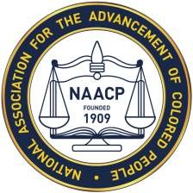
The Albemarle- Charlottesville NAACP
Celebrates
FOUNDERS’ DAY
Sunday, February 18, 2018
4 P.M.
Zion Union Baptist Church
1015 Preston Avenue
Charlottesville, VA. 22903

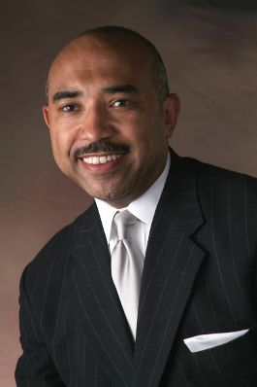
Guest Speaker: Gary L. Flowers
Host of the Gary Flowers Show

Refreshments Served Immediately Following Program

