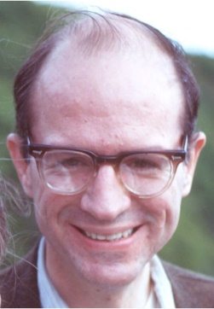
JAMES F. KING
James F. "J" King, Jr., 81, died peacefully on Saturday, January 6, 2018, in Charlottesville, Virginia. He is survived by his spouse, Margaret P. "Peggy" King; and his brother, William L. King and spouse, Lucia. King was educated in public schools in Washington, D.C. and graduated from Harvard College. He worked creating policy for the U.S. Department of Health, Education and Welfare in Washington, D.C. and retired early to Charlottesville, Virginia. Committed to improving the lives of all of us, our society, and our environment, he was full of enthusiasm and proposals on how we could continually improve and make and use the best processes and outcomes in our community. He encouraged our leaders to state their individual 50-Year Vision for our community and compiled their visions with all other citizen submissions. He advocated for a City reversion proposal, ran once as an independent for Charlottesville City Council and was invited to teach leadership development by many non-profits in this community, in Virginia and in other states. King devoted many hours to civic associations, including the Boards of the Albemarle Charlottesville National Association for the Advancement of Colored People (NAACP), Charlottesville and Virginia National Organization for Women (NOW), League of Women Voters, Criterion Associates, Lewis Mountain and Fry's Spring Neighborhood Associations, Charlottesville Federation of Neighborhood Associations, and Virginia Association of Neighborhoods. Because of his quiet and steadfast dedication, he had a positive influence on many people's lives locally and beyond. A celebration gathering and reception to honor King's life will be held from 12:30 until 2 p.m. at Fry's Spring Beach Club, 2512 Jefferson Park Avenue, Charlottesville, Virginia, on Sunday, January 28, 2018. All friends and neighbors are welcome to come, share, and reminisce. In lieu of flowers, memorial gifts may be given to the Albemarle Charlottesville NAACP, Box 1522, Charlottesville, VA 22902, or http://www.albemarle-cvillenaacp.org/ to support their daily efforts for justice and the civil rights of all people.

